WHAT WE DO — RURAL INFRASTRUCTURE
Creating Spaces That Strengthen Rural Communities
Strong communities need more than individual support. They also need safe, functional and accessible spaces in which people can learn, gather, work, stay and participate in community life.
ASSF's rural infrastructure initiatives have focused on identifying practical gaps at the community level and developing or supporting facilities that respond to those needs. The emphasis is not on construction for its own sake, but on creating infrastructure with a clear and lasting community purpose.
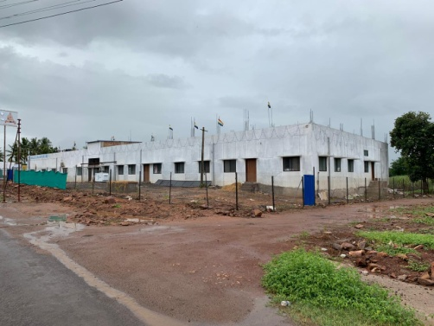
Original ASSF project photograph — rural community infrastructure.

Why Rural Infrastructure Matters
In many rural areas, a missing facility can affect an entire community. The absence of a suitable community hall can limit gatherings and cultural activities. Inadequate accommodation can make it difficult for teachers and staff to remain close to schools. Poor sanitation can affect public health. A lack of functional spaces can restrict the ability of communities to organise, learn and come together.
Our approach has therefore been to look beyond the physical structure and ask a more important question: What will this space enable the community to do?

Infrastructure With a Purpose

Community Spaces
Creating or improving spaces that can support gatherings, cultural activities, learning, libraries and other community needs.

Educational Support Infrastructure
Improving facilities that help schools and educational institutions function more effectively, including appropriate accommodation for staff.

Essential Public Amenities
Supporting basic facilities that contribute to sanitation, dignity, safety and healthier community environments.

Heritage & Cultural Spaces
Creating spaces that support cultural continuity, community participation and the preservation of local traditions.

Staff Quarters for a Rural School
At Hosur, ASSF responded to a practical challenge faced by an educational institution serving rural students. Teachers and staff were commuting from distant locations because suitable accommodation was not available near the school.
Following a site assessment, ASSF supported the alteration of an existing building to create accommodation for school and institutional staff. The completed work created 14 rooms, providing a more practical living arrangement for the people responsible for running the institution.
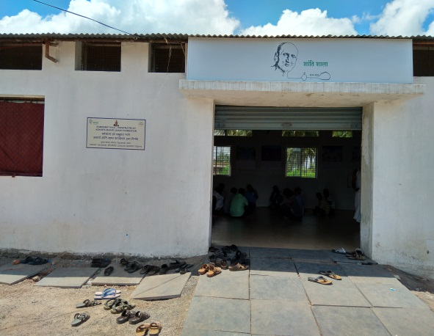
Original ASSF photograph — completed staff-quarter facility.
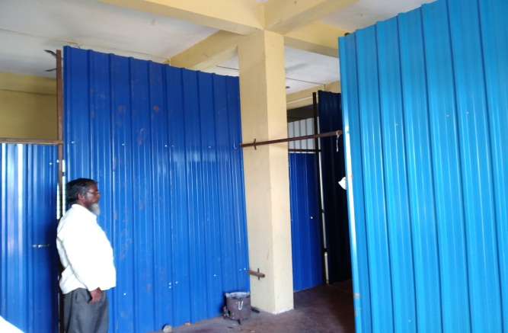
Original ASSF photograph — completed facility.

Renovating a Community Hall
In Yarnal, the existing community hall had deteriorated significantly and there was no comparable public community space in the surrounding area. After a site assessment and discussions with local leaders, ASSF took up its renovation and expansion.
The renewed facility was intended to serve multiple community purposes—including a library, cultural activities, family gatherings and other public events. The objective was to turn an underused and deteriorating structure into a functional space that could remain useful to the village over the long term.
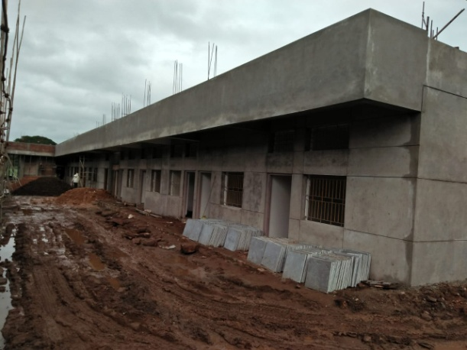
Original ASSF photograph — community hall project.
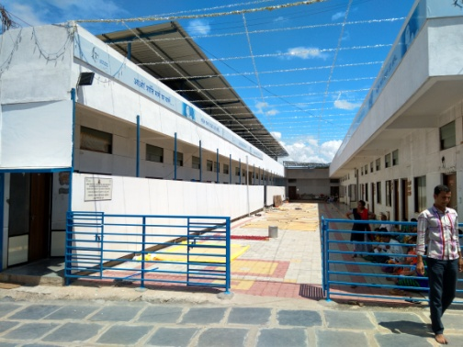
Original ASSF photograph — completed community facility.

Samudaya Bhavan at Yarnal
Yarnal is a rural village in Belagavi district surrounded by several neighbouring villages. The local community and Gram Panchayat identified the absence of a suitable community facility as an important gap.
In response, ASSF developed plans for a Samudaya Bhavan with facilities intended to support community gatherings, cultural programmes, discourses and other local events, while also providing accommodation for visitors.
The project was developed following a community request, site assessment, planning and architectural design. Land was made available by community supporters for the proposed facility, and the completed project created a larger shared space intended to serve the wider rural community.
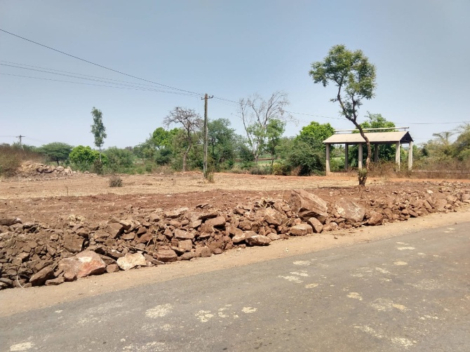
Original ASSF photograph — site before development.
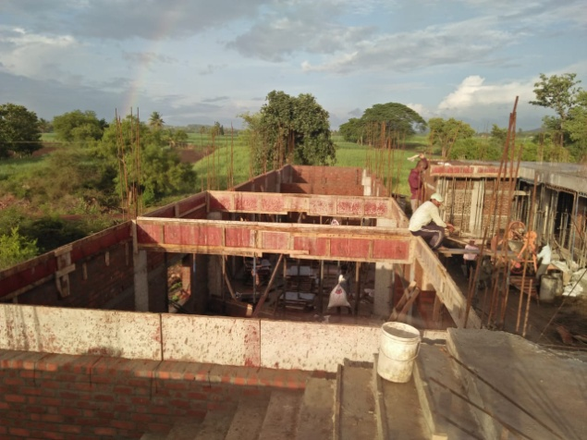
Original ASSF photograph — Samudaya Bhavan under construction.
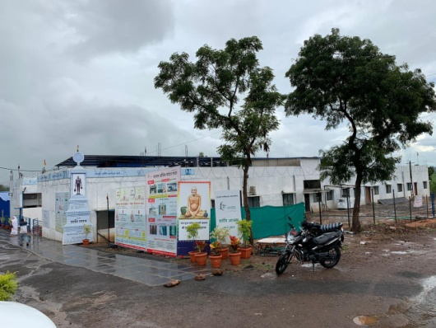
Original ASSF photograph — completed Samudaya Bhavan.

Improving Access to Basic Sanitation
Rural infrastructure can also mean addressing very basic gaps that directly affect public health and dignity.
At Yarnal, ASSF responded to requests from local residents regarding the absence of public sanitation facilities. The Foundation surveyed the situation and approached the local Zilla Panchayat to facilitate the construction of public toilet blocks through government funds. ASSF recommended that the facility include running water, lighting and appropriate sewage disposal.
Following discussions and coordination with the authorities, the public toilet blocks were constructed on land provided by the Shri Chandraprabhu Digambar Jain Mandir Committee. This is an example of ASSF's role not only as an implementing organisation, but also as a facilitator that can help communities connect with public systems and resources.
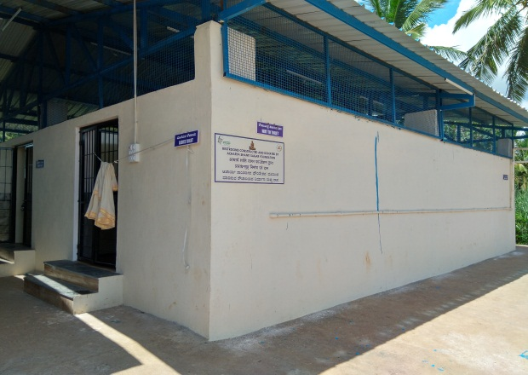
Original ASSF photograph — completed public sanitation facility.
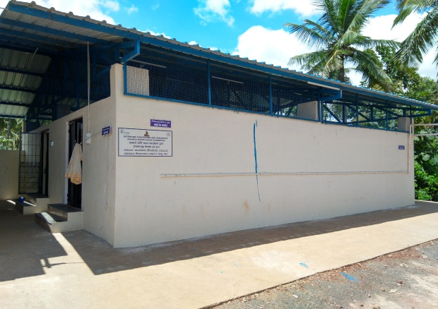
Original ASSF photograph — completed public sanitation facility.

Shanti Stambh — A Cultural Landmark
Rural infrastructure can also create spaces that carry cultural memory forward.
ASSF constructed the Shanti Stambh in memory of Pratham Acharya Shri Shantisagarji Maharaj. A statue approximately six feet in height is installed above the stambh, while the four sides carry engraved representations of his life history.
The landmark was formally inaugurated on 8 February 2020 in the presence of Acharya Shri 108 Vardhaman Sagarji Maharaj and his Sangh, with Dr. D. Veerendra Heggade participating in the inauguration.

Original ASSF graphic — Shanti Stambh design / representation.

How We Approach Rural Infrastructure
Our infrastructure work begins with the need, not the structure. A project is considered in the context of the people who will use it and the purpose it is expected to serve.

01 — Listen & Assess
Understand the requirement through requests from communities and institutions, followed by a site assessment.

02 — Define the Purpose
Establish what the facility must enable and who it is intended to serve.

03 — Plan Carefully
Develop practical plans with appropriate architectural and technical inputs.

04 — Build or Facilitate
Depending on the need, ASSF may undertake the work directly or work with public authorities and local institutions to enable the required infrastructure.

05 — Create Long-Term Value
Focus on facilities that remain useful to the community beyond the completion of the project.

Building for Community, Not Just for Today
The value of rural infrastructure is ultimately measured by what happens after the building is completed: children learn, families gather, teachers can live closer to their schools, visitors can be accommodated, communities gain access to essential amenities, and shared spaces become part of everyday life.
ASSF's rural infrastructure work reflects the Foundation's broader commitment to strengthening the communities that sustain social, cultural and institutional life.
Infrastructure with purpose. Spaces with lasting value.
In Service of Heritage and Humanity

